CERTIFICATE OF ANALYSIS

Product Name: 1,4-二溴萘 1,4-Dibromonaphthalene
CAS No.: 83-53-4 MF：C10H6Br2
Manufacture Date: 2020-08-31 Batch No.: VANZ-200801
Report Date: 2020-08-31 Quantity: 220kg
Expiry Date: 2022-08-30 Standard: In-house Standard

Items | Specifications | Results

Appearance | Off-white powder to crystal | Conforms
Identification ( HPLC ) | Retention time of principle peak in the chromatogram  obtained with the sample solution should match with that of the principal peak in chromatogram obtained with standard solution in the test for “Assay by HPLC.” | Conforms
Assay（HPLC） | ≥98.0% | 99.14%
Solubility | Soluble in Chloroform-d | Conforms
Loss on drying | 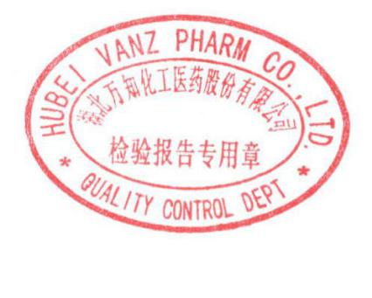  ≤0.5% | 0.22%
Conclusion | Meet in-house specifications.

Tested by: Wang Xiaohang Checked by: Chen Tao Issued by: Lei Xiaogang

